Presentation by

Name: Djeneba
Last name: Sakanoko
Level 2
Class time: 12 Am

What's cooking

Definition

Cooking is the set of technologies for preparing food for human consumption.
It is diverse around the world. It has become a cultural fact, an element of heritage and national or family identity and much more.

For me food plays an important role in the conviviality of the house and therefore of the family.

Présentation food 1

Baked fish with Attiéké ( cassava couscous)

Ingredients
- Fish
- Onions
- Tomatoes
- Garlic
- Oil
- Salt
- Ginger
- Seasoning cube
- Pepper
- Spicy
- Mustard
- Timer : 45 min 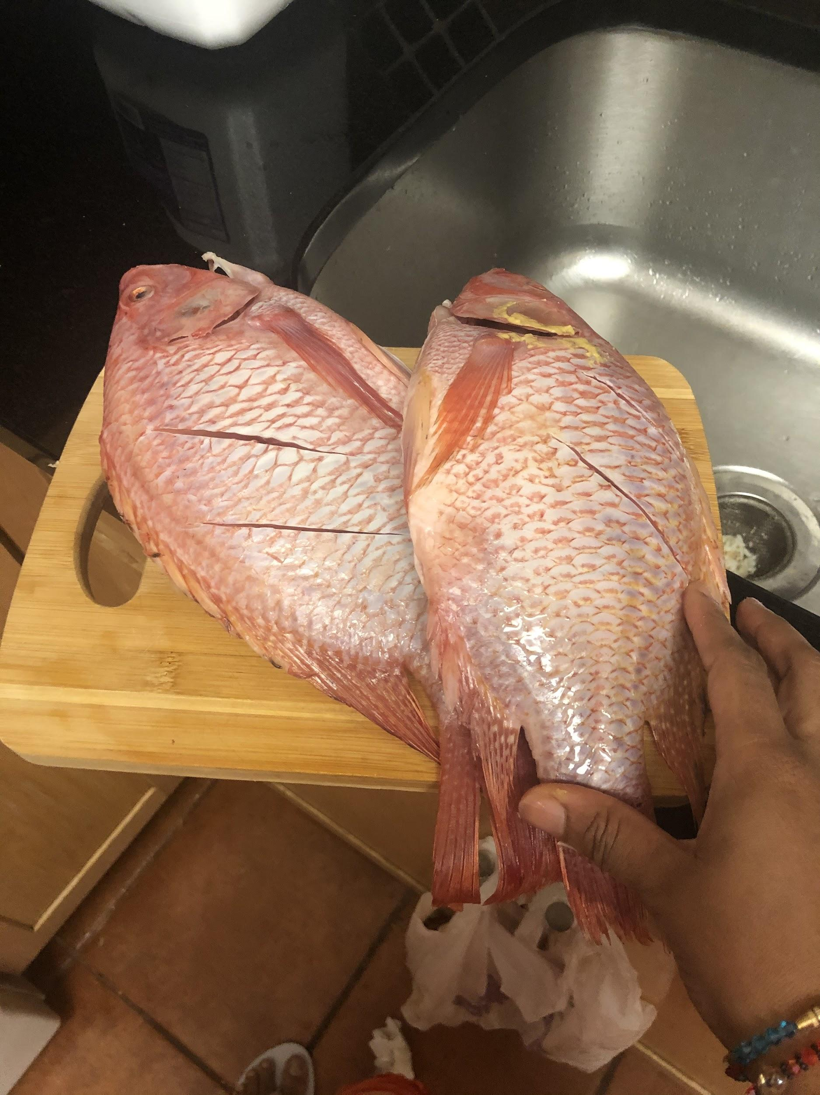
Fish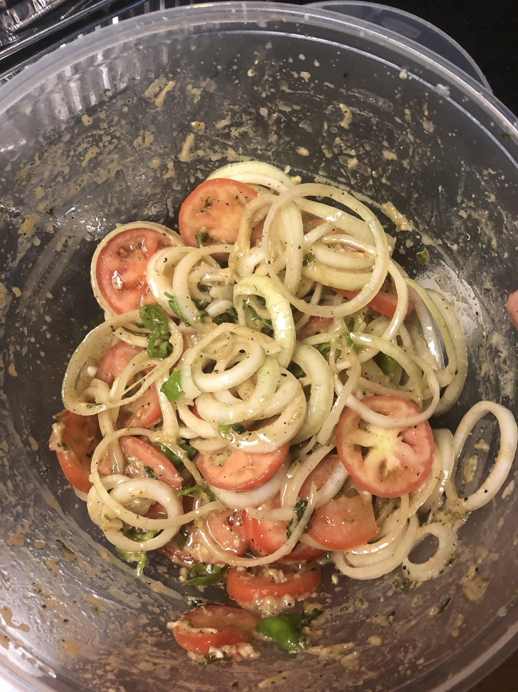
Mix the chopped oignon, tomatoes, spicy...
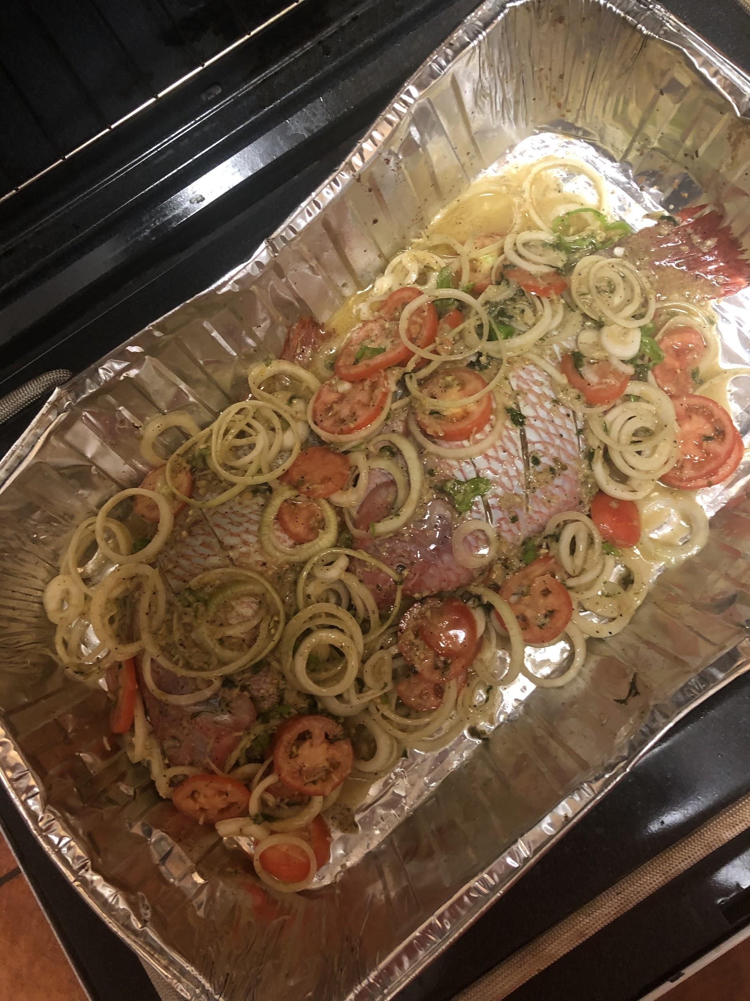
Bake for 45 min
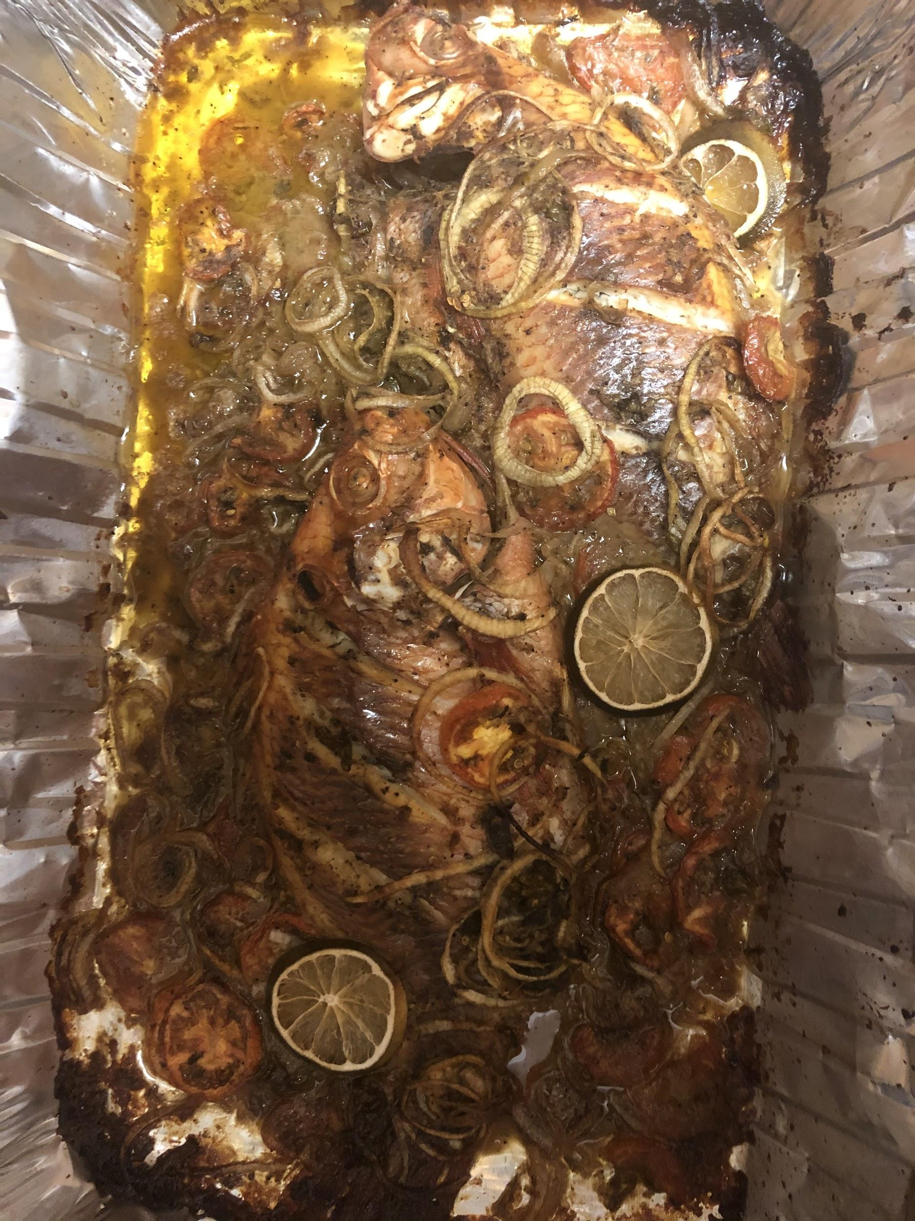
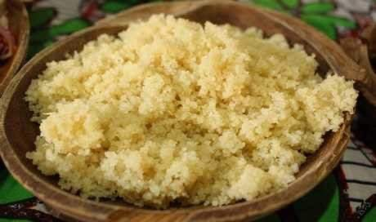
Attiéké

Presentation food 2

Of Alloco with braising meat

Ingredients
- Plantains
- Oil
- Meat
- Onions
- Pepper
- Spicy
- Salt
- Seasoning cubes
Timer: 45 min
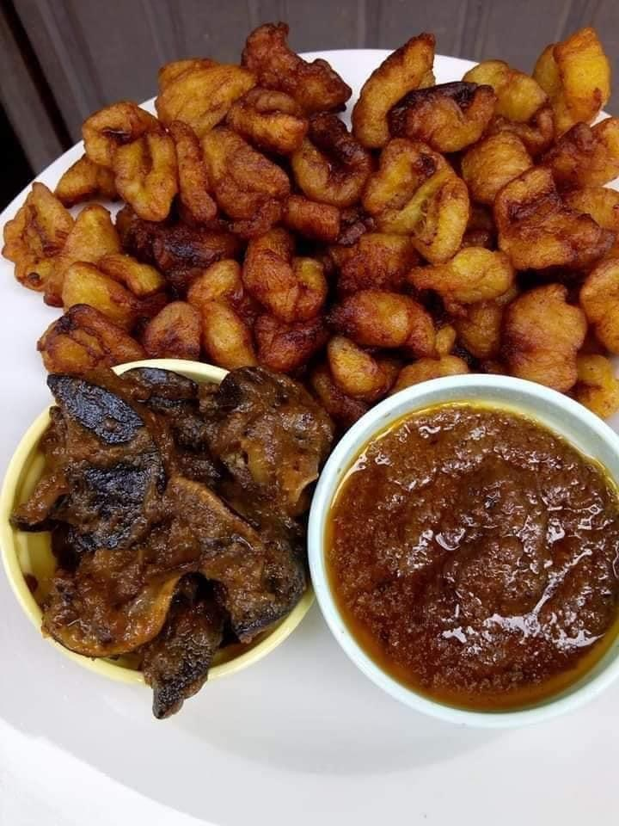

Presentation food 3

Spinach sauce with rice

Ingredients

- Spinach
- Onions
- Tomatoes
- Garlic
- Spicy
- Oil
- Water
- Meat, chicken
- Pepper
- Okra
- Rice
- Salt
Timer: 1h30min

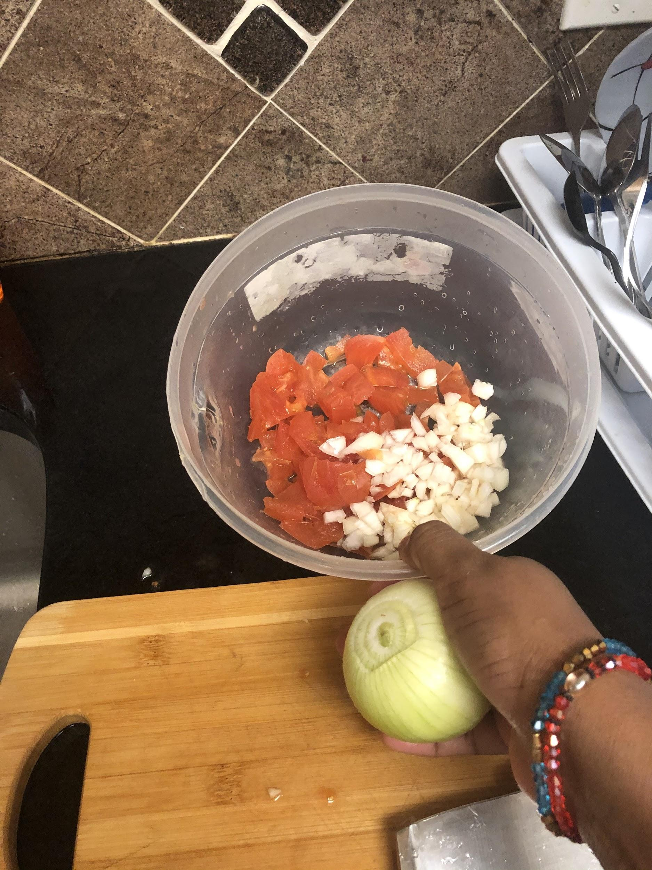
Cut onion, tomatoes and garlic

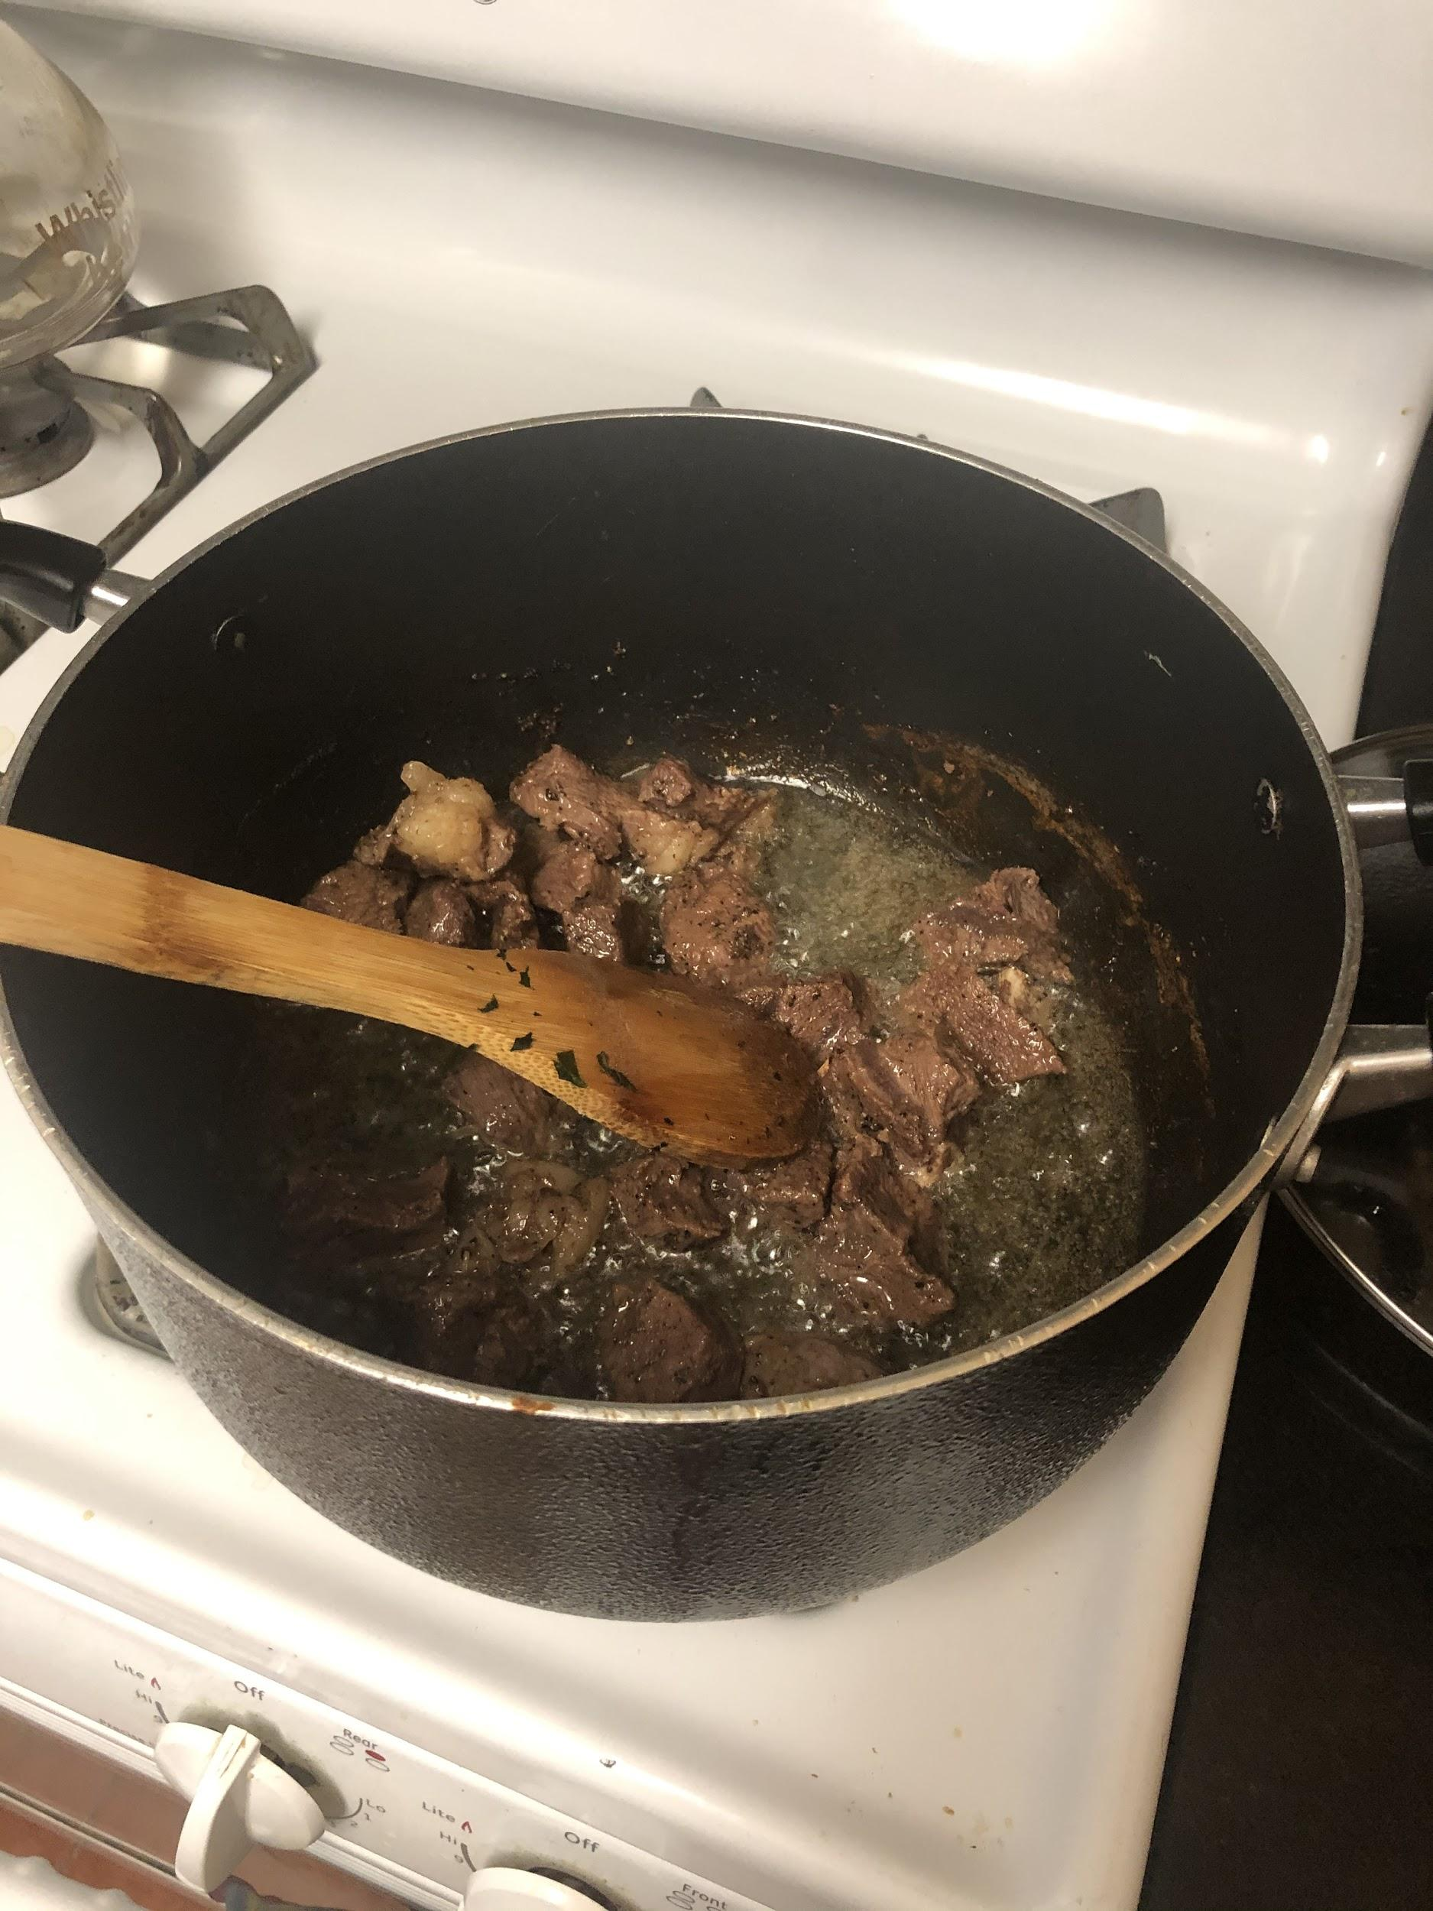
Put oil and grill the meat
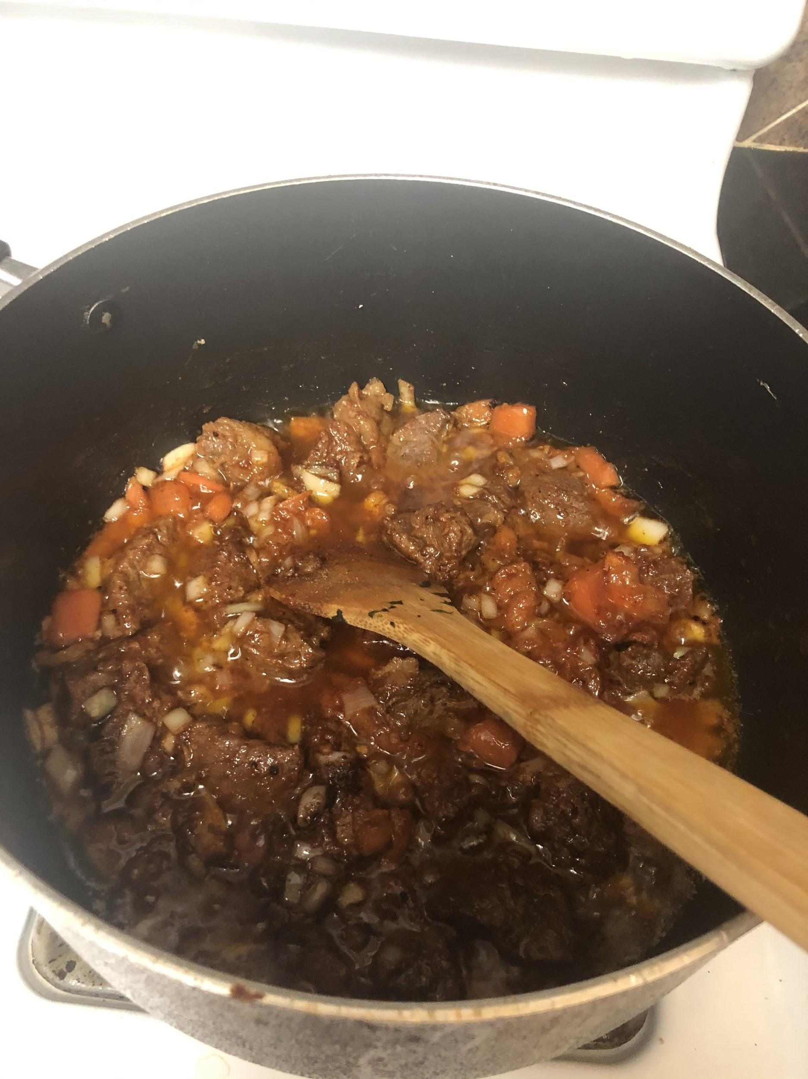
Mix onions, tomatoes and garlic
Put on pepper in the meat. After put water

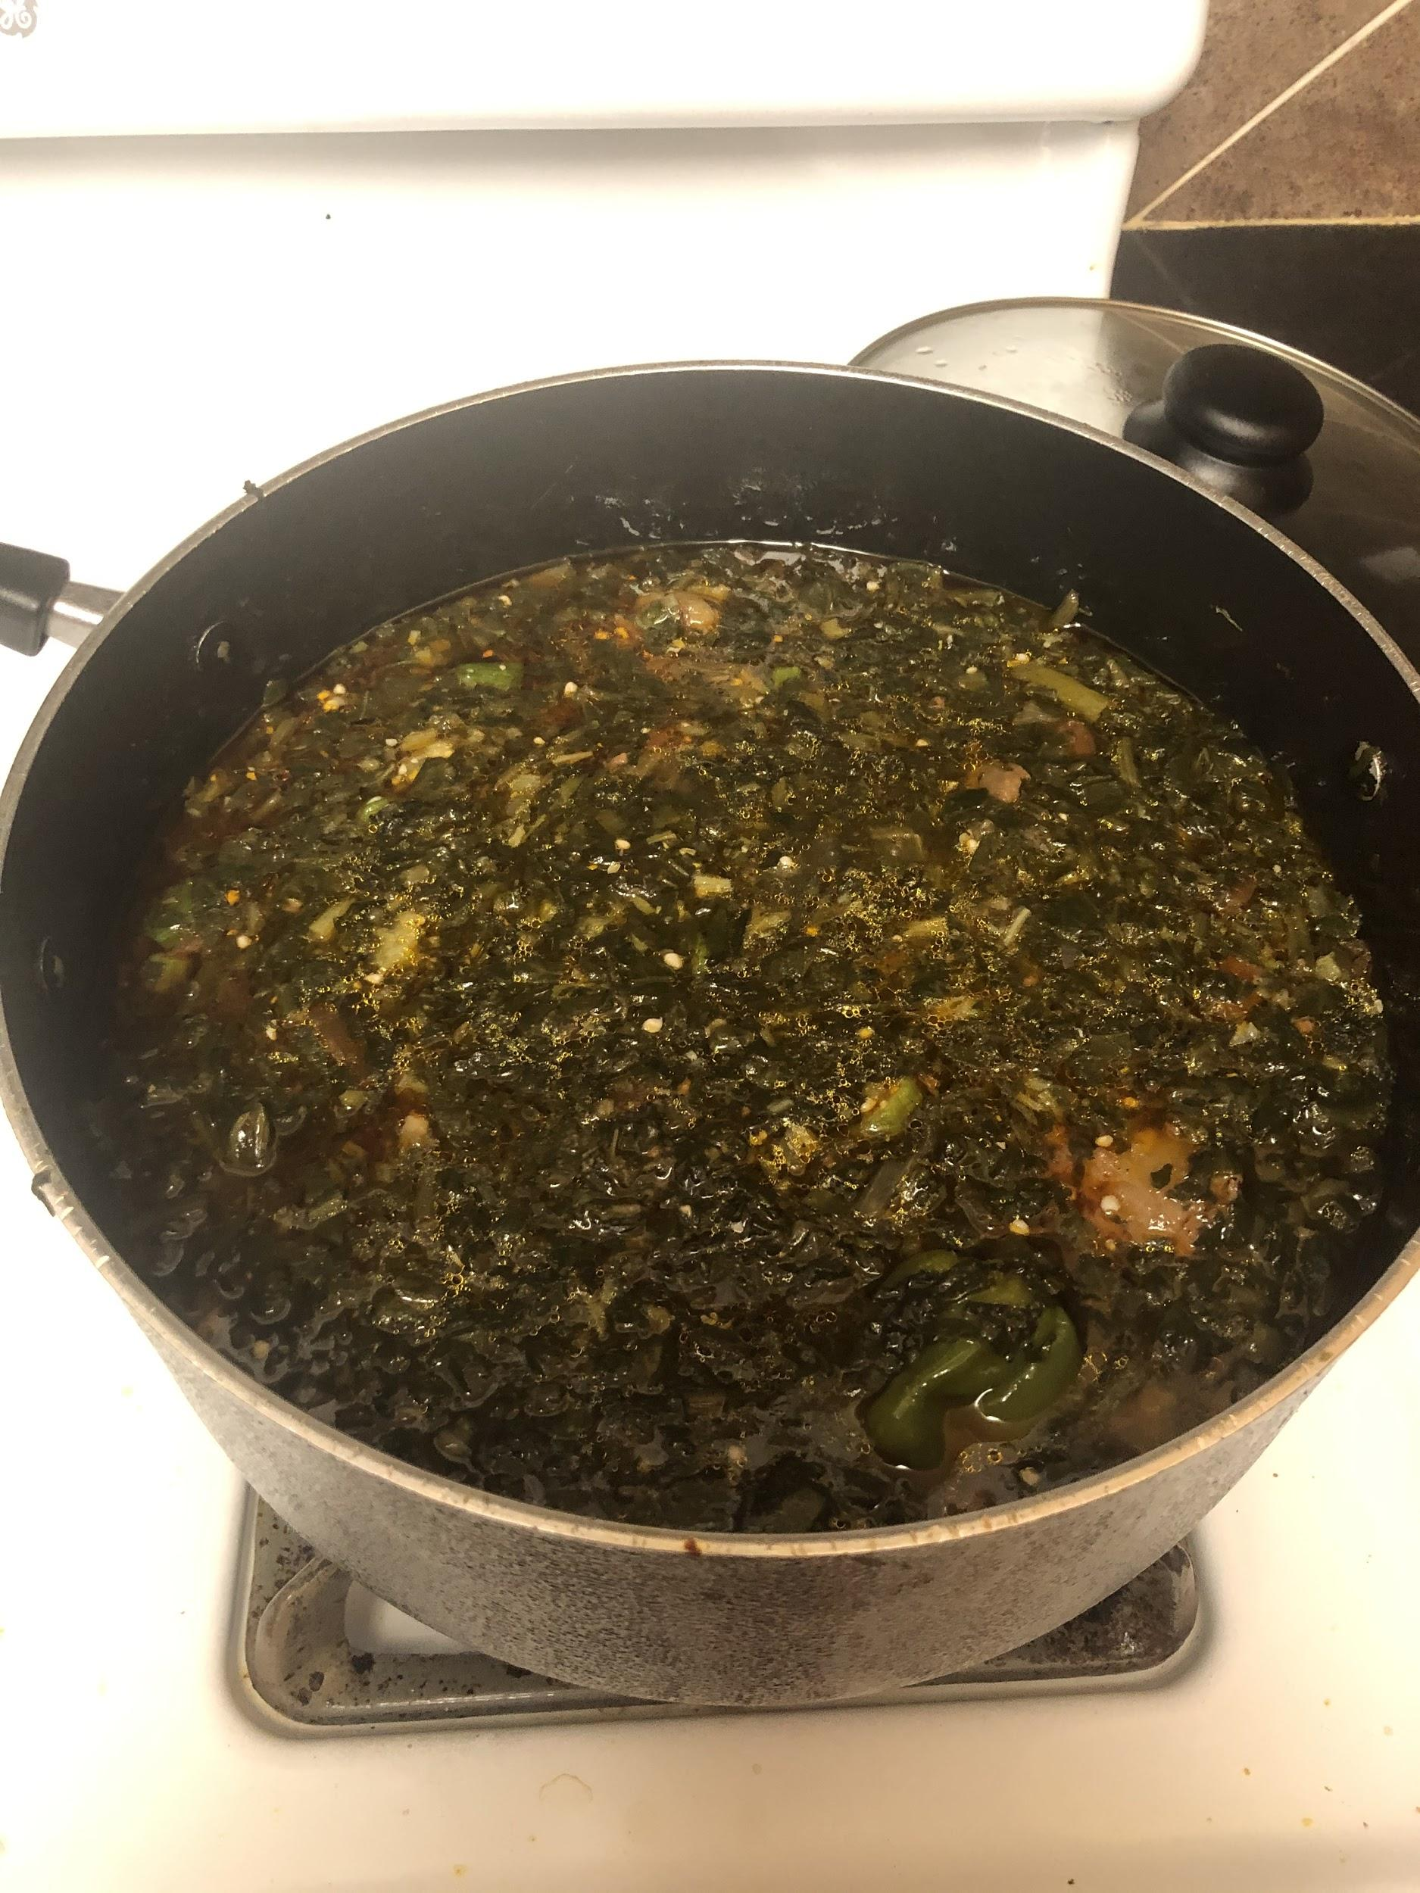

Put on the spinach, okra and spicy, salt and seasoning cubes

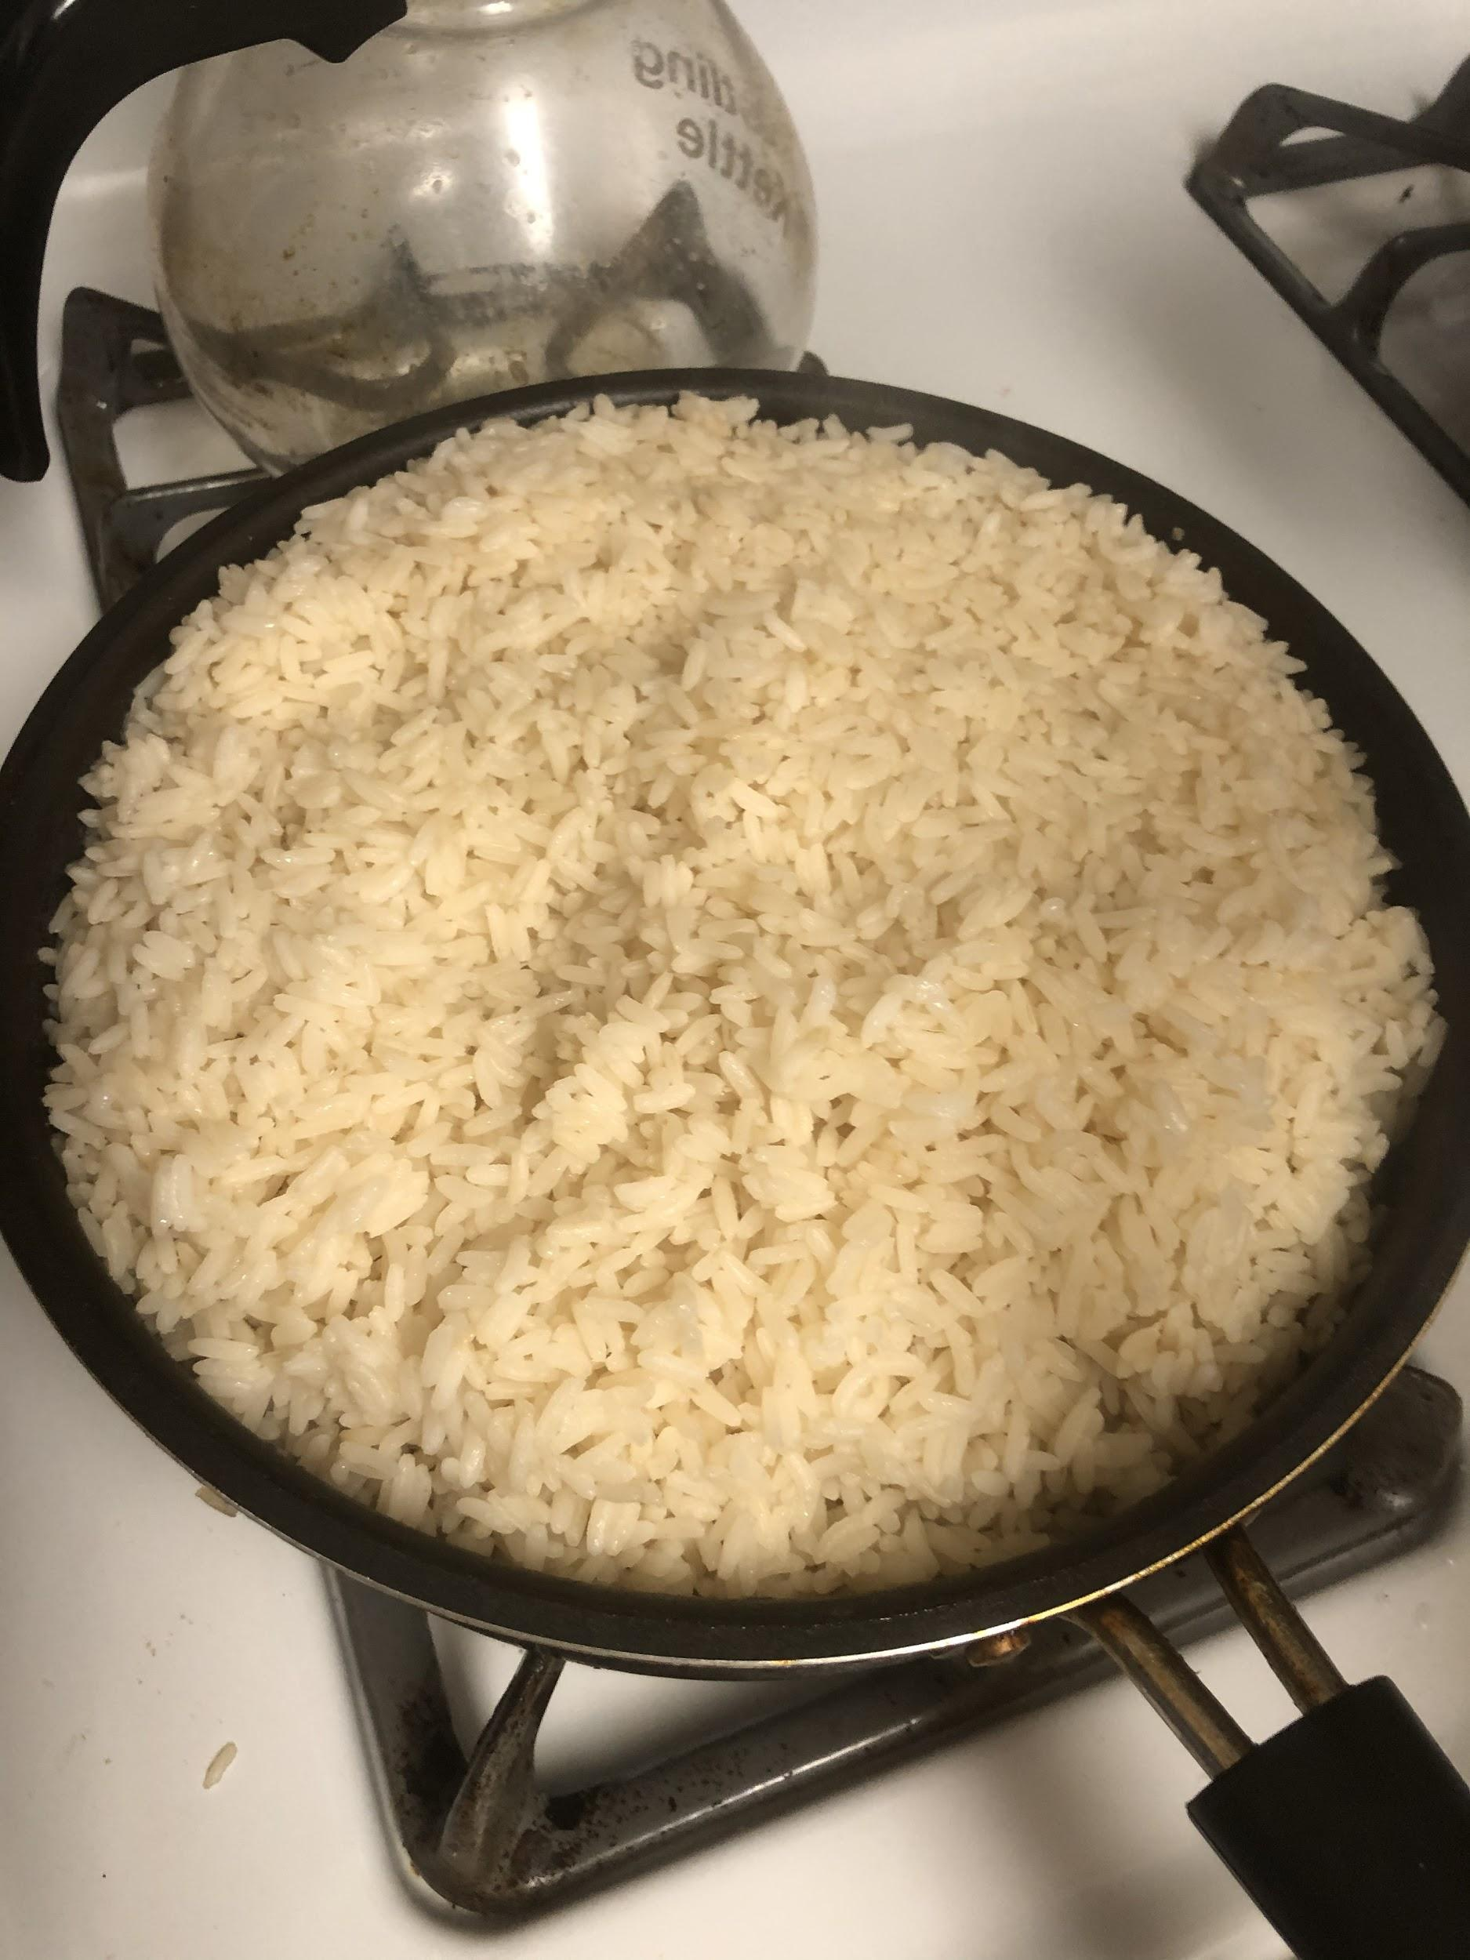

Cook rice

